Meta Description:
TikTok Marketing is a promotional way to advertise a brand, products, or services with the aim of audience engagement, conversion, and traffic.
Images:
https://drive.google.com/drive/folders/1K-iy56JekviDOfiWnd0ecroWT03F3YA9
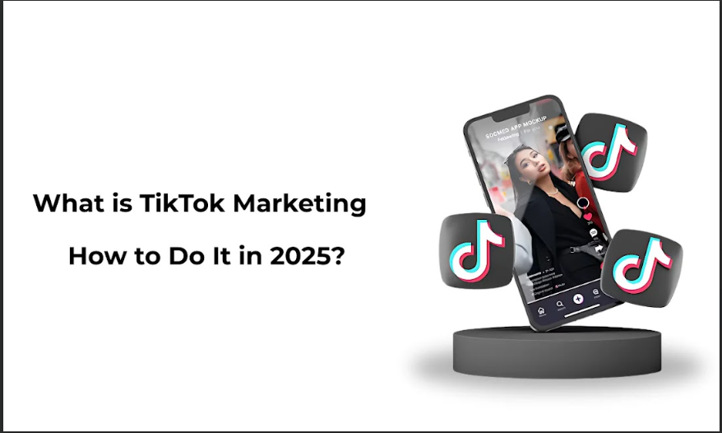

What is TikTok Marketing & How to Do It in 2025?
When we look forward to the year 2025 and beyond, there are platforms that are still rather up for grabbing the audience's attention, and TikTok is the most among all. However, for the best results, it is necessary for every brand to understand the working process of TikTok marketing. In this blog, we will discuss what TikTok marketing is, its major components, and why it is necessary for brands to utilize TikTok marketing.
Let’s dive deep into the world of TikTok marketing to understand everything related to it in more detail.

What is TikTok Marketing?
TikTok marketing is a process of using the TikTok platform for the promotion of a brand, product, or service. Brands use this platform while interacting with their customers, developing content that goes viral, and creating brand identity and sales. The platform offers comfort in terms of branding as it is focused on the freedom of creativity and the real personalities of the users.

The Rise of TikTok:
TikTok, which was initially introduced as Musical.ly in 2016, started to gain popularity. It has a short-form video and contains various content that entices the site's algorithm. Based on the projections, TikTok should retain its popularity through 2025 with billions of monthly active users.

Key Components of TikTok Marketing:
Firstly, brands should comprehend TikTok essentials for it to be effective for the brand. These are the primary components of an efficient TikTok promotion plan.
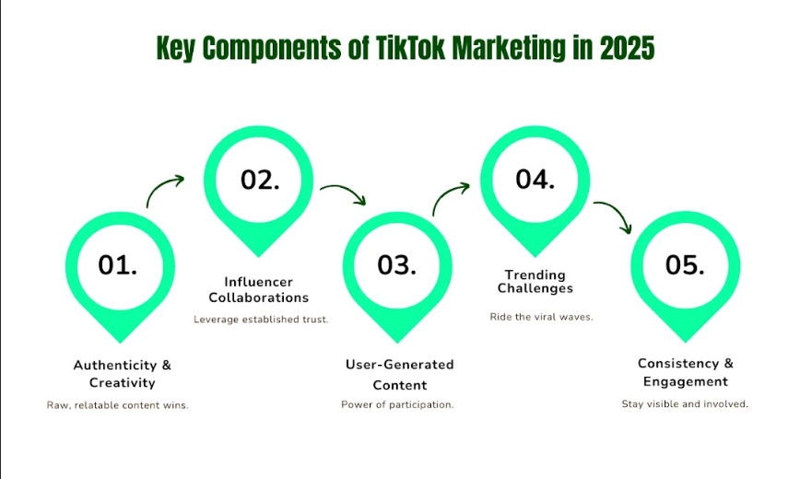

Authenticity and Creativity:
For your brand growth, your TikTok must feature authentic and creative content rather than anything unnecessary. It’s necessary to create videos that will appeal to the consumers’ emotions and will be engaging to them. You can foster the humor, telling, and sharing of stories as well as focusing on themes that people are likely to understand. Being real is important to users because they will easily know if something is real or fake and will not get the chance to engage with a fake one.

Influencer Collaborations
Influencer collaboration is a notable feature when working with TikTok. Advertisers can find access to established communities through this method. Many people hold influencers working on TikTok in high esteem due to the authority they wield in their niche markets. It is always more effective for influencers to advertise their followers naturally through other posts that display the products of a certain brand.

User-Generated Content (UGC)
Another key activity that needs to be performed is the promotion of generating content by users. Marketers must employ activities such as challenges or campaigns on the platform to encourage users to come up with content that incorporates the brand. This makes engagement rise and increases the loyalty of users and fans to the brand they are helping to create.

Trends and Challenges
It is crucial to keep up with trends on TikTok or the challenges you came across earlier. Make sure the influencers with whom you are going to collaborate actively engage in popular challenges and incorporate them into the message sent by brands. This not only makes the post visible but also locates it in the most recent trending issues concerning the brand.

Consistency and Engagement
Consistency is vital on TikTok. Consumers should continue updating their brands frequently on the internet to ensure they keep engaging the audience. Also, the attitude toward comments and messages increases the brand–consumer relatedness and proves that the latter is cared about.

TikTok Ad Specs and Placement Types
To achieve an effective advert placement and advert placement types on TikTok, it is vital to understand the specifications of the platform. TikTok provides clients with the same set of advertising formats that are appropriate for various advertising campaigns and enterprises.

Ad Specifications
The specifications that TikTok advertising requires for placement of the adverts are as follows:
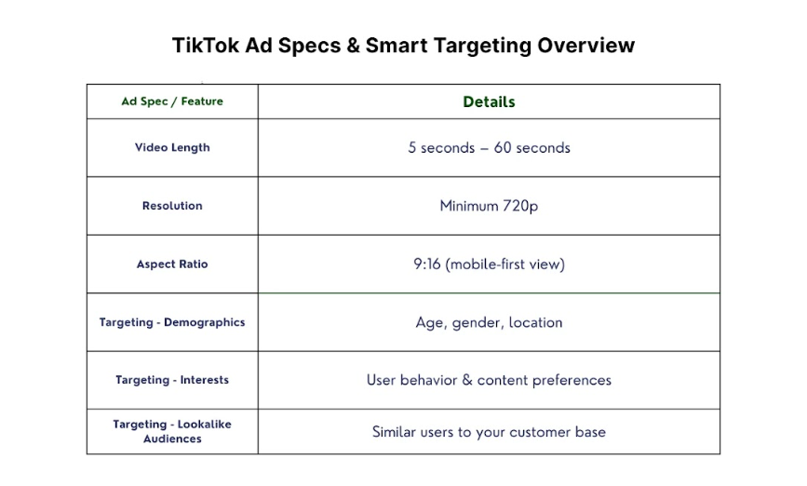
- Video Length: TikTok ads have a desired time length of between five seconds to one minute. The shorter videos are used when making a quick statement that should be powerful enough, and the extended videos are used when there is more information that needs to be passed.
- Size: The ad is at least 720p so that you can see it clearly and with good quality.
- Media Aspect Ratio: The recommended media aspect ratio is 9:16 because such a ratio was designed to fit perfectly on the app interface, which is horizontal like a mobile phone screen.

Placement Types
TikTok has several types of ad placements, and they are the following:
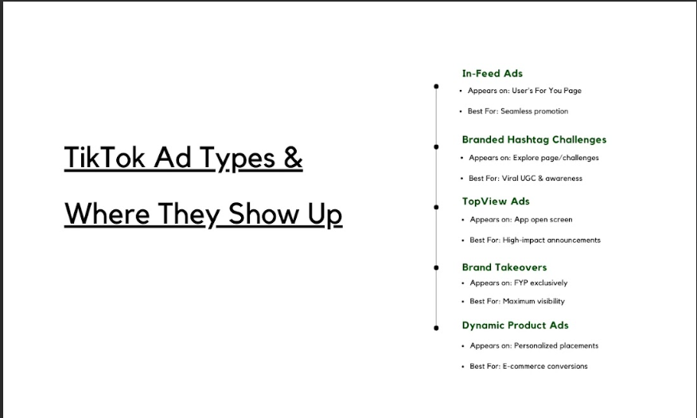

1. In-Feed Ads
In-feed ads are planted right within the feed section of a user’s feed on the You Page (FYP). These ads do not interfere with the flow of the content so much and therefore are less invasive. This kind of advertisement is suitable for brand promotion and advertising because the customers can be identified to be engaged in consuming content.

2. Branded Hashtag Challenges
The demand is to come up with content that shall fit a certain branded hashtag. These are the right tools to drive the concept of the ‘word of the mouth’ way to the clients and help to get a better brand awareness. Hashtags also operate on TikTok’s social nature as a content creation platform.

3. TopView Ads
TopView ads are placed when a user first time opens the TikTok application. This position is ideal for announcements and promotions because it is easily noticeable by all users of the site. TopView ads are most suitable for those advertisers who want to introduce new products or services into the market.

4. Brand Takeovers
Brand takeover ads can be briefly explained as an instance where a brand hijacks a TikTok user’s FYP. This specific occupation scheme is very relevant because the audience sees only the content connected with the brand during the takeover.

5. Dynamic Product Ads
Dynamic product adverts provide information about products on the products such as prices and their status. These ads are appropriate for e-commerce companies and their products. On dynamic ads, customers can view products and buy from the advert.

Targeting Options
TikTok also offers various targeting options, allowing brands to target audiences of their choice. Key targeting options include:
- Demographics: The user acquisition can also be achieved through targeting age, sex, and geographical location of the users.
- Interests: Here, another targeting available for TikTok is the one based on the users’ Interests and their behaviors.
- Similar Targeting: There is similar targeting, according to which brands can target the audience that is similar to their client base.

Measuring Success
Based on these notions, brands should track certain indicators or metrics based on the result expected from the TikTok campaign, namely engagement rate, outreach, and conversion. TikTok offers analytics that deliver useful information that can then be used in evaluating the success of a campaign.

Why TikTok Marketing is Important for Your Business?
TikTok has changed the direction in which consumers take a path for videos in terms of duration and persistence. To the businesses, this is an opportunity to reach out to a large market base that occupies the different ranks of society. Here is a breakdown of why the use of TikTok in your business marketing is essential:
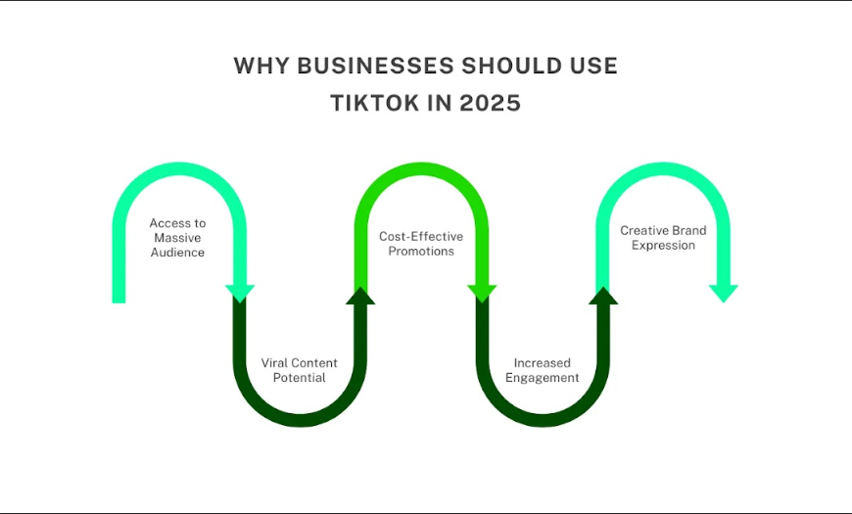

1. Access to a Massive Audience
Currently, more than one billion people use TikTok daily. This vast group of users allows organizations to reach out to potential customers than any other marketing strategy. TikTok has users from the young generations, from Gen Z to the older generation as well, so it is easy to target the desired audience through segmentation.

2. Viral Potential
Another capability that can be identified with TikTok is the shareability of content produced by the application. Potential reach on a well-crafted video can get you millions of views within a few days. Therefore, it remains a good marketing strategy for businesses. This can have a great effect on brand awareness as well as visitors to the website or stores.

3. Cost-Effective Marketing
Unlike other forms of advertising that are expensive in terms of costs to be incurred, TikTok can be effective in reaching out to a large number of people. It is relatively easy to grow the audience organically, and even paid promotion is quite inexpensive. This puts TikTok as a preferable choice of marketing platforms for small businesses because they do not have to spend so much money to put their products across.

4. Enhanced Brand Engagement
Duets, stitches, and challenges – all of these features of TikTok ever induce the users into creative mode. Such a level of interaction is very useful to create the inner communicative environment and engage people and businesses at the communication level. According to the current research, the engaged customers are likely to promote the brands in the market.

5. Creative Freedom
The TikTok platform allows for creation and risk-taking, which sets its format tenet on creativity. Marketing companies in particular can use this platform through which they can market their products or services in unique styles that they wouldn’t usually do. This creativity poses the opportunity for brands to stand out from the competition, a feature that is key to grabbing the consumers’ attention on the internet.

Factors to Consider While Creating a TikTok Strategy in 2025
There are certain trends that will define TikTok marketing in the years to come. Here are some points that describe the changing dynamics of the major elements that businesses need to contemplate to develop a successful TikTok approach:

1. Understand TikTok’s Algorithm:
TikTok offers an algorithm that intends to present material that is likely to interest the user. To achieve this, businesses will have to realize how this algorithm operates. That is why it is advisable to create and disseminate content of higher quality that appeals to the target consumer base. It is also important to refer to trends, hashtags, and challenges that are in vogue at the moment, as they will help boost the visibility of the video.

2. Authenticity and Brand Voice
Specifically, the TikTok audience expects and appreciates authenticity and finding content that’s similar to their life. While selecting appropriate content and its presentation, every business must consider that the content aligns with the brand voice and values. It is better to provide more useful and interesting information rather than to advertise. At least try and make it appear that you’re trying to befriend your reader, not sell to him. It makes users place their trust in what it is that you are giving them, and this will make them embrace you as a brand.

3. Leveraging Trends and Challenges
TikTok has trends and challenges, which would help in enhancing a content’s popularity. Try to observe the trends and find ways to engage in them naturally. Creating branded challenges is one of the ways to promote the brand and encourage users to create content with brand hashtags.

4. Content Diversity
When writing blog posts, do not limit yourself to presenting your readers with one type of content; at least present them with variation. Diversify your videos, including product demonstration videos and instructional videos, and customer-created videos. Not only does it make it less likely that all of your feed will be boring at the same time, but also, this way you will reach different segments of your target audience.

5. Collaborations and Influencers
Working with TikTok influencers and other brands also helps the business to increase its overall audience. Ensure you go for a suitable influencer who is in principle with the company and who is in touch with the customers emotionally. Particularly timely, effective partnerships can add to the overall quality and reliability of your brand.

6. Utilize TikTok’s Features
Examines TikTok features that can be beneficial for your marketing strategy. Use duets, stitches, and hashtags to better capture the users’ attention and employ them in engaging with the app. Some of these are also used in engaging the audience, while others are useful in reaching out to groups already present on the platform.

7. Measure and Analyze Performance
To achieve a good result, you should measure and analyze the results of your content on TikTok at least once a week. You can measure that by using specific built-in tools of TikTok to measure results, likes, comments, the number of views, subscribers, and followers. It helps you to adjust the future campaigns towards an even more proper solution if you understand what topics your audience is keen on.

8. Stay Adaptable
This is something that people must know because the digital environment is dynamic, and the same applies to TikTok. So, make sure you are willing to change your mind and become adaptable. You should expect to quickly adapt to a new technology whenever new features, trends, and algorithms are released. Staying tuned with the updates of TikTok will help in making sure that your marketing is still functioning optimally.

9. Integrate with Other Marketing Channels
To make TikTok as effective as possible, it should be integrated into the grander marketing plan. To apply this knowledge, you should start using it in a social platform other than TikTok, in your email marketing campaigns, or even in traditional advertising. Brand integration and marketing communication can help various channels improve the vision and outcomes of marketing.

10. Prioritizing User Experience
Ultimately, the success of your TikTok strategy hinges on the user experience. Make sure that what you produce is interesting, entertaining, and comprehensible without having to struggle. Think about all the stages between awareness of the video and the action the user has to take. A smooth and pleasant experience to which a user is exposed will give them the perception to want to learn more about your brand.

10 Pro TikTok Marketing 2025 Tips
Let’s talk about 10 pro tips that can help you streamline your strategies and achieve better results.
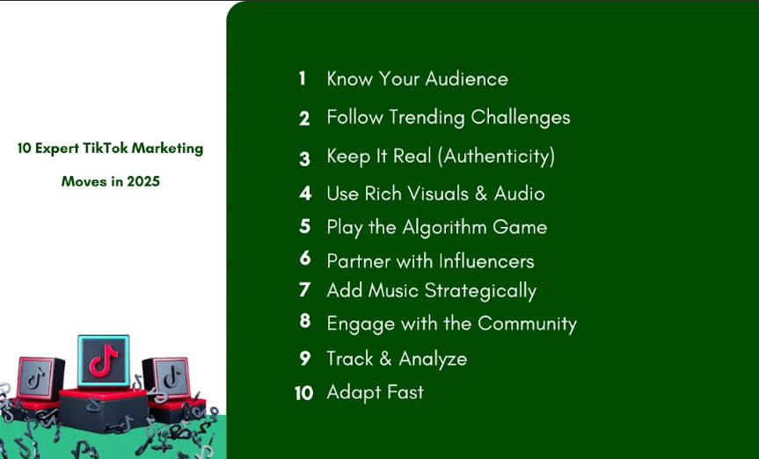

1. Learn About the Audience
Understanding the kind of audiences that use TikTok is very important when it comes to marketing on that platform. At present, by 2025 it will have mainly reached the target audience among the first-time internet users in the age group between 13 to 30 years, the generation Z and Young Millennials. By targeting the right population, you can share content that is relevant to them and the kind that fascinates them, as this will ensure that they are well-engaged.

2. Embrace Trending Challenges
TikTok lives for trends and the concept of competition or challenge. Content that can immediately popularize the subject can be easily identified by brands that can capitalize on it. This can be done by following the current trends, hashtags, and challenges, and then trying to come up with ways that the brand can either join in or facilitate such trends.

3. Focus on Authenticity
Authenticity reigns supreme on TikTok. As much as audiences value the creative formatting of ads, they would rather be fed real content than something that has been created to denote the actual picture of an advert. You should present your brand's authenticity, spirit, and daily stories to earn the consumers’ trust and communicate on a different level.

4. Use Rich Media Formats
TikTok has many advantages, and one of the biggest is the essence of the media used on the platform. Maximize the use of pictures and graphics, nice music and narration, and captivating stories respectively. Entice interest through the use of user-generated content, influencers, as well as different features that would engage users in the videos.

5. Optimize for the Algorithm
Understanding TikTok’s algorithm is key. Consequently, the emphasis should be placed on the content that incites discussions with the target audience, for example, through likes, comments, or share options. Frequent and proper posting and enhancing the video description with the most appropriate keywords can enhance its ranking on the algorithm.

6. Collaborate with Influencers
The influencers present on TikTok do have considerable power over their follower base. So, work with influencers who adhere to its values, as they will help reveal the brand to a wider audience. An even greater advantage of micro-influencers is that they have more interaction and a closer association with the audience.

7. Incorporate Music and Sound
To sum up, music is the vital aspect that defines the uniqueness of TikTok, as the videos shared contain music. Incorporate music that is actively popular at the moment or overwrite your own songs, which can become associated with your business. Anything that can catch the ears of your target audience will enhance the possibility of sharing as well as the memorability of your content.

8. Engage with the Community
It is very important to make the audience participate. Reveal users’ opinions about your brand and get involved in the conversations by appreciating user-generated content. People like to spend their time where they feel a sense of belonging, and by making this feeling strong, you can establish your brand easily.

9. Experiment with TikTok’s Features
TikTok frequently updates its features. As usual, experiment with new features in order to produce a new variety of content, including duets, stitches, and other effects. Being relevant is important in the current world of business as it establishes a company or a brand as an industry leader.

10. Measure and Analyze
Data-driven decision-making is essential. When it comes to statistics, TikTok offers several in-built features that will help you monitor performance and analyse the audience behavior. Strongly bound to its regular schedule analysis to refine your strategies, gather more information, and improve the results.

Tools for TikTok Marketing: Paid & Free

Free Tools:
- Canva: it is very helpful in creating engaging graphics, or even TikTok printables, or holding cards. It also contains templates that are compatible with the creation of content and the use of social platforms.
- TikTok Analytics: Use the functions of the application to track the level of its popularity and other indicators. It is very helpful for supporting basic demographic information of the audiences, as well as the kind of content that is well-received by them.
- Trend Spotlight: To remain informed about the current trends on TikTok, utilize distinguished apps like TrendSpot. Staying up on the topic of the moment makes you able to produce content that reflects its current popularity.

Paid Tools:
- Sprout Social: Coordinate and schedule the operations of your TikTok account with other social media platforms with Sprout Social. It also provides analytical and scheduling functionality.
- Popular Companies: Start using AdEspresso to create, control, and enhance any TikTok advertising campaign. It provides A/B testing and analytics to optimize the ad revenue.
- Union Metrics: Monitor and evaluate the influencer marketing campaigns with Union Metrics. It offers further information regarding effective engagement and overall return on investment for influencer marketing.

Conclusion:
TikTok is now very popular and is expanding its opportunities in many directions. Utmost all, it is vital to stay well-informed, be true to one’s core, and take up the mantle of being a real consumer companion, and the future of TikTok marketing in the year 2025 is bright.
Has your business realized that it's time for enhancing the technology and TikTok marketing tactics, but you have been contemplating where to begin? Three Angle Marketing services cover the development of excellent social media advertising strategies that will address the intended audience and produce measurable outcomes. Get in touch with us now to find out more about how we can revolutionize your TikTok account as well as prepare your brand for success in the year 2025 and beyond. Ready to leave your claim on TikTok? Let us assist you with that.

